**3d level design assignment 2**

Due date: 14 july

Reference video: <https://www.youtube.com/watch?v=eggGC5J6O_k>

### **The tutorial**

Side note: i dont rmb if you can flap in this tutorial scene, but i will assume player knows absolutely nothing and doesnt know flapping is a thing

[flight steering tutorial](https://youtu.be/eggGC5J6O_k?t=40)

-> players have to fly through a tunnel of clouds. Player is given a text on screen introducing keys/ controls on how to control flight direction

-> the brightness at the end of the tunnel acts as a positive space. (idk what else to say here, it is what it is. Actually i guess i can say it acts as an objective for player to head towards? But its kind of straightforward though O|<)

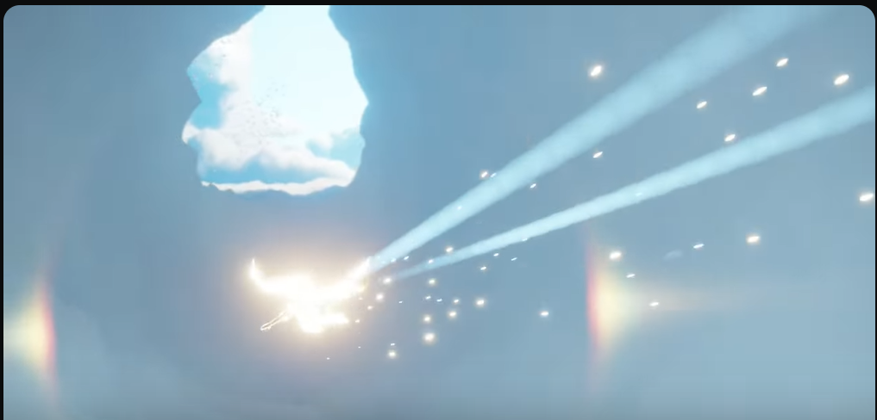

[introduction to objective of the game](https://youtu.be/eggGC5J6O_k?t=50)

-> birds fly into player’s view at the end of the cloud tunnel. They can be seen flying to the right, towards a beam of light in the distance.

->The birds’ flight serves as a practical line to direct the player while the beam of light serves as a landmark

-> in the distance, a beam of light, a hero prop acting as a landmark, can be seen.

-> with the birds’ flying direction and the landmark, it gives player information that they need to make their way there.

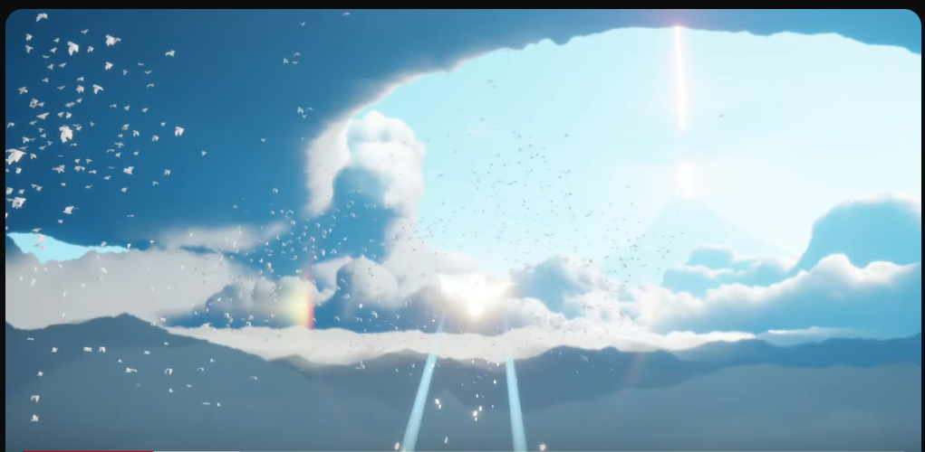



Cinematic shot introducing the beam of light into the scene

[guiding direction](https://youtu.be/eggGC5J6O_k?t=65)

-> camera change from Cinematic view to focus on player character.

-> uses flat sight angle

-> with birds acting as a path for players to follow, the scene makes use of symmetry to guide players forwards towards the beam of light (acting as landmark)

-> by flying in the intended direction, the player flies out of the enclosed clouds.

-> the lack of clouds surrounding the edge of player’s screen (wide open space) gives players a sense of freedom while also acting as an area for players to explore with the controls of the game

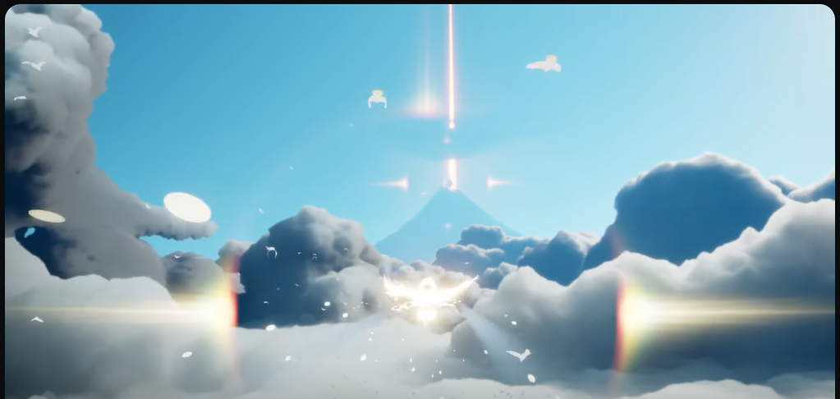



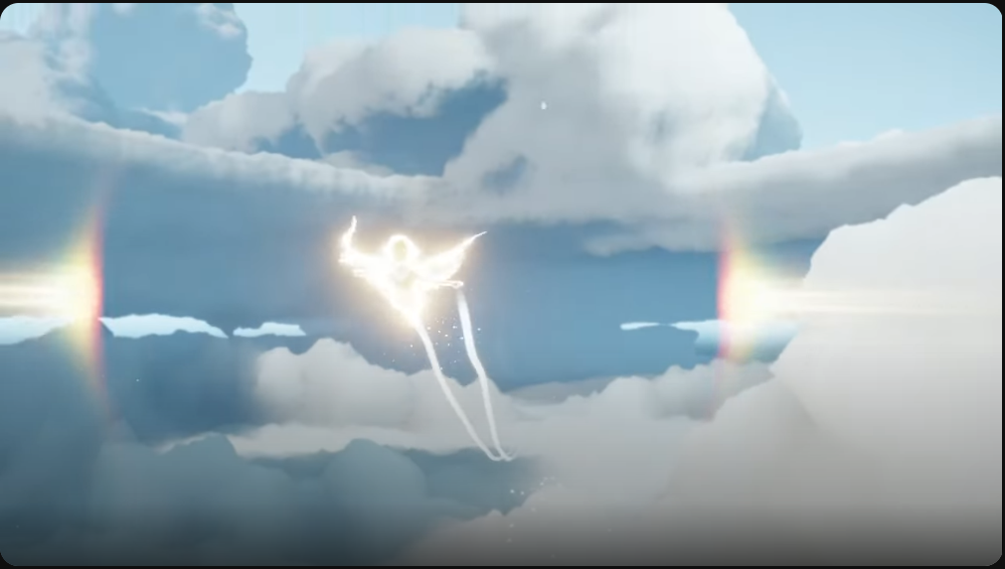

Back view of player, taken from 1.34 but it shows there is no clear direction to go to

(player can tell not supposed to go this way)

[introduction to mantas and controlling own elevation](https://youtu.be/eggGC5J6O_k?t=76)

-> a manta appears from beneath the player and flies upwards above player.

-> text on bottom of screen tells player how to fly higher and lower

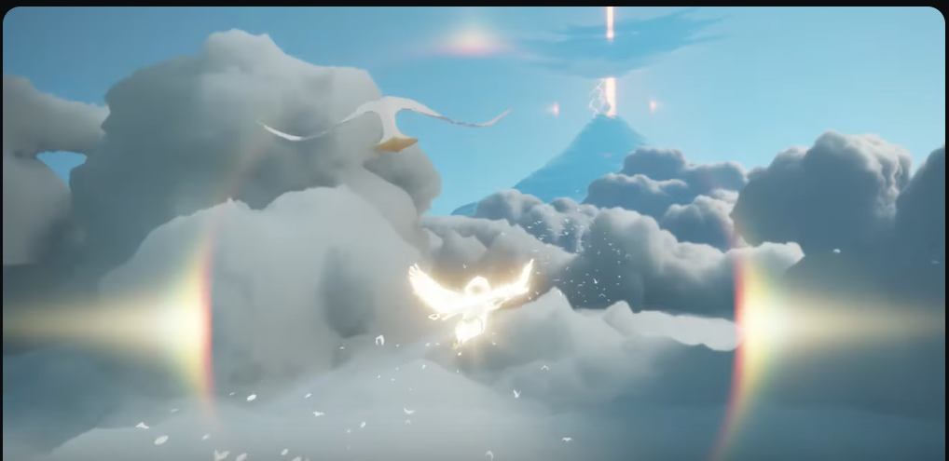



-> clouds placed at bottom of screen to act as obstacle for players to fly over.

-> forces player to try out controls to fly higher in order to avoid obstacle

-> in case players choose not to do anything/ didnt see text at bottom of screen, the clouds will push player away and upwards past itself

(i could technically talk about having no flaps to move higher, but i realized this is a steering tutorial, so player should be able to move higher by using controls anyways)

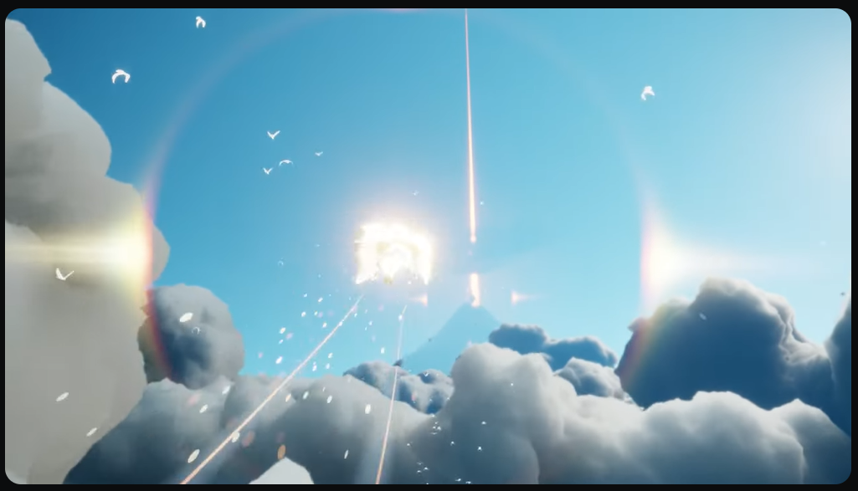



Full shot of the scene (without bottom gradient and video ui)

Note to self: after convert to word document, put a red box over bottom clouds (focus of the shot, i did not search through and delete video ui for nth. Am doing it on google just so i dont have excuse to be stuck in bed n not be able to do on laptop. its possible to do on phone so no slack

‘ -’

Wow, no progress. Who could have thought O|<

Also, only covered 1.30/ 6.30 of video :’D)

Depressed sight angle

-> introduction to new scene area (?, was all clouds before, now player will dive beneath the clouds to see ocean)

-> foreshadowing for player before they enter cutscene, which player will fall from the sky down to the ground

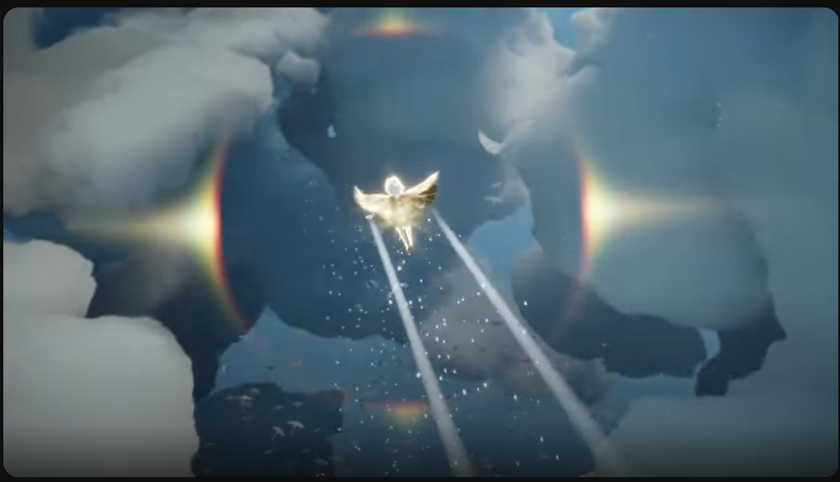

1.38 of vid

Nver fucking mind player lose all light before falling down below the clouds

Rewrite tis section to “prepare player to go down”

[Elevated sight angle](https://youtu.be/eggGC5J6O_k)

-> landmark to guide player to head towards it

-> scene is generally symmetrical (also to guide player towards landmark)

-> player’s colour creates contrast with surrounding area so it grabs players’ attention and allows them to spot their character easily (colour theory yay)

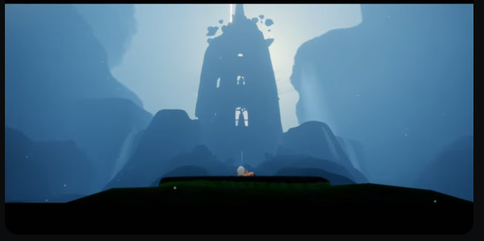

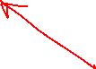

2.43 of vid

This is still part of cutscene, but introducing player to aviary village (before main gameplay)

Draw arrow using word to emphasize symmetry

Also circle player to show colour contrast and focus on player

[Spotlight](https://youtu.be/eggGC5J6O_k?t=174)

-> guides players focus to the area (and subject)

-> suggests to player that they have to do something to subject in order to progress

-> surrounding area apart from spotlight is darker to create colour contrast (can technically also be called lighting contrast) to guide player towards brighter area

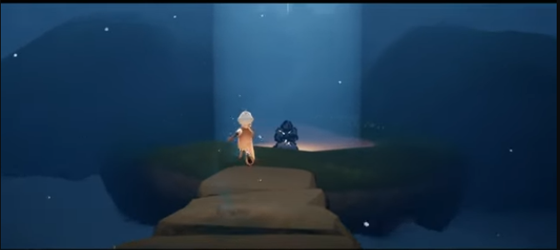



Around 2.54 of vid

Should subject be considered as negative space in the scene?

If consider only the lighted area, spirit do be the negative area of the shot

A bit repeat about focus on subject a bit much at this point

Just saw position point in notes

Can saw spirit in center catch players attention, but then again, repeat a bit too much about focus at this point

[Introduction to new control](https://youtu.be/eggGC5J6O_k?t=175)

-> first introduction of interaction button to player

-> very simple, singular ui that is easy for players to understand to press the button/ keyboard key in order to interact with subject

-> (not shown in screenshot) player will pull out their candle to raise above the subject, which aligns with ui flame design so players will pull out candle when approaching subject in the future

[apparently playstation controller has **a dedicated candle button** to pull out/ put away candle, the light of the controller also flickers with the candle. WHERES OUR DEDICATED CANDLE BUTTON ON PC D:

[the said controller light flickering](https://www.reddit.com/r/SkyGame/comments/13jd7a7/just_realized_that_the_ps4_ps5_controllers_do/?utm_source=share&utm_medium=android_app&utm_name=androidcss&utm_term=13&utm_content=share_button)

Just realised after rewatching, the controller didnt have a dedicated button. They had their menu open so its probably jus controller press button lmao. Still though, cool controller feature D:]

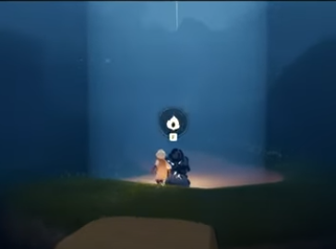

I just realised the video in 360p quality O|<

Am lazy to take screenshot again though

Yes i am that lazy

[First interaction with spirit](https://youtu.be/eggGC5J6O_k?t=180)

-> cutscene shows spirit shocked by player’s flame on their candle

-> spirit turns to door behind it, camera briefly focuses on said door

-> conveys to player that the door is the objective they need to head to next

-> spirit also beckons to player to follow him before running towards the door (in case player didnt see the door being focused on by the camera)

-> the path on the ground also also contrasts with the cool colours of the grass and surrounding area so it can easily catch players’ attention.

-> the path also has a practical line to guide the player to follow the path towards the door in the distance.

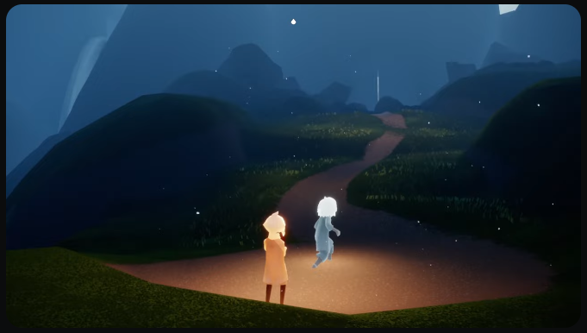



This be only 3 of 6.30 of vid :’D

[The door](https://youtu.be/eggGC5J6O_k?t=217)

-> the area is very dark apart from the mechanism on the door

-> gets player to focus on the mechanism and suggests that player need to interact with it to open the door

-> player also uses the candle to trigger the mechanism to open the door, showing that the universe of sky relies heavily on the player’s flame for their daily life (?, a bit weirdly phrased, but flame super important in sky yes)

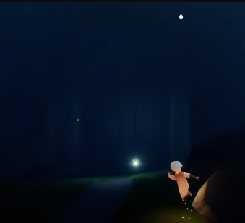

The rest of video is technically player unlocking buildings in the lifeless village (an npc’s quest) , so yeah, tutorial over :D. Obviously, this is a very new tutorial and introduction to new starting point in sky, I did not start sky seeing this cutscene. This area was only introduced like november/ december last year O|< . It’s a great tutorial using level design to introduce and guide the player the game controls, mechanics and objective in my opinion (also events in sky, yes the spirit in the video is an event npc, but it is permanent).



The end?

Also side note, its sky’s 5th anniversary :D

Yes the 5th anniversary event is currently running and will end on 26th july. I think the dev talk in the game is over though O|<. BUT, ti was super cool :DDDDD. I may or may not have stolen some screenshots from their dev talk stream ‘ -’.

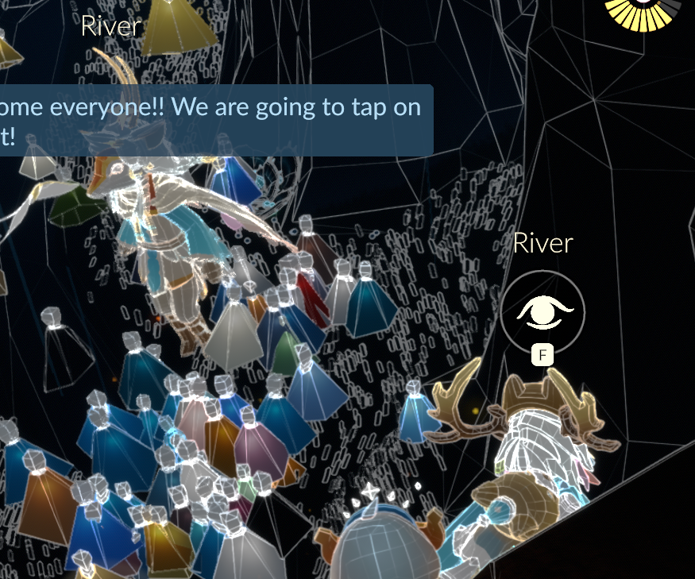

Time limited concept art walkthrough with game dev

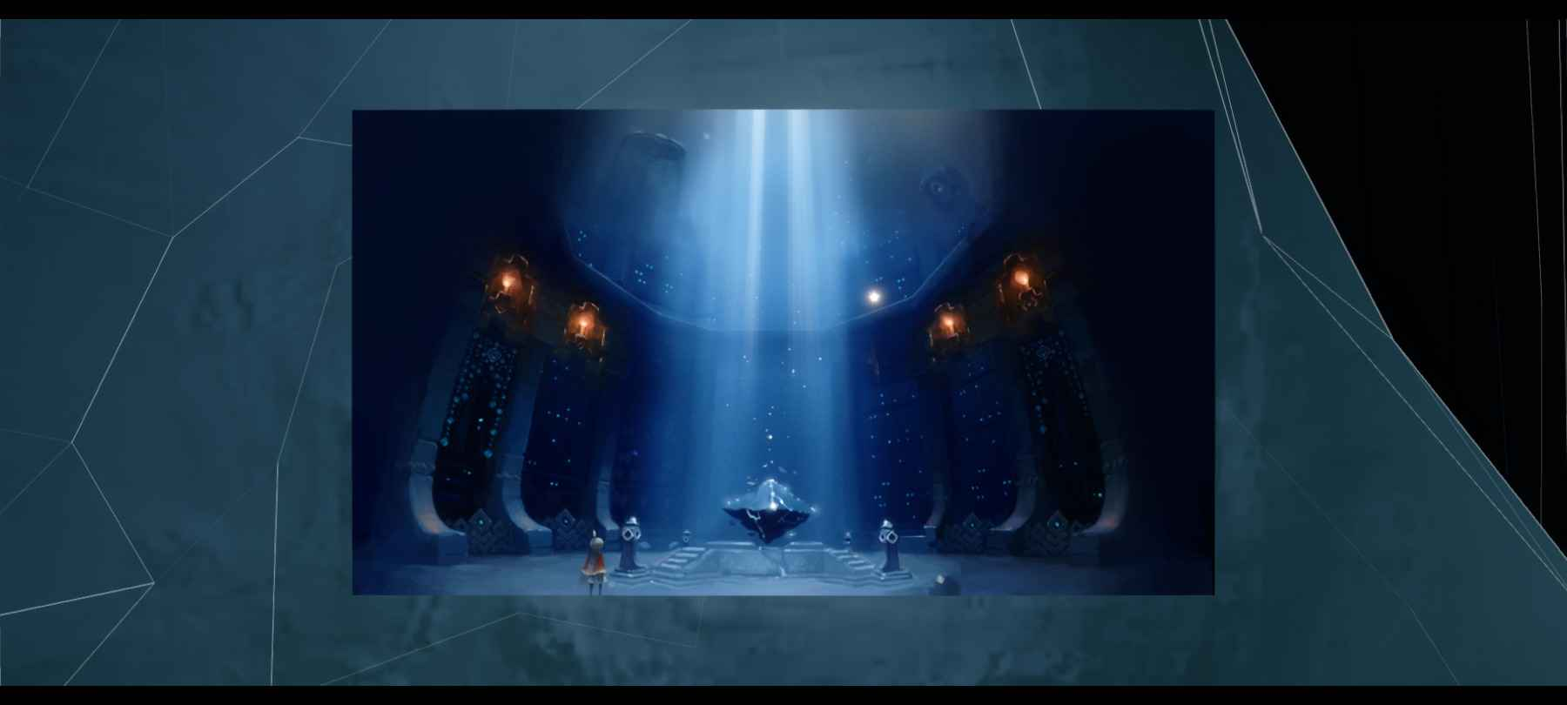

Concept art of the vault

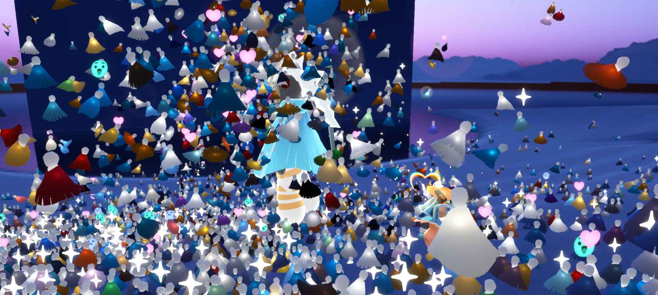

Players swarming the dev during music performance

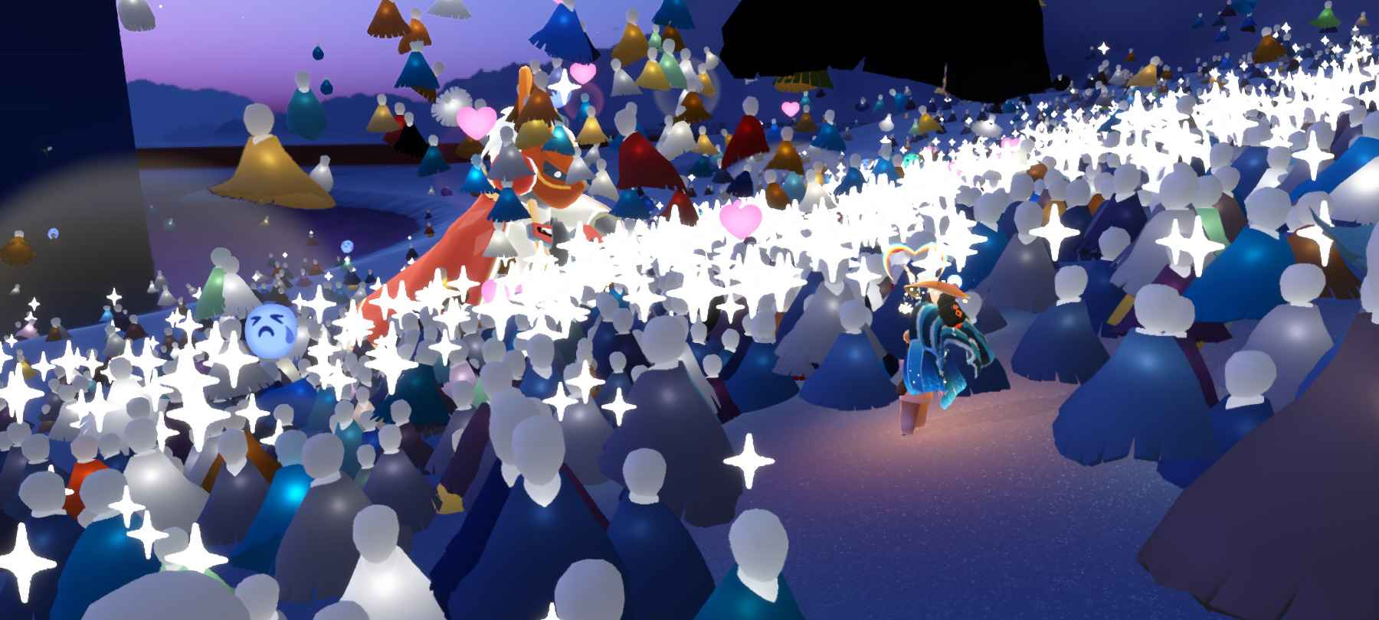

One of the music performances

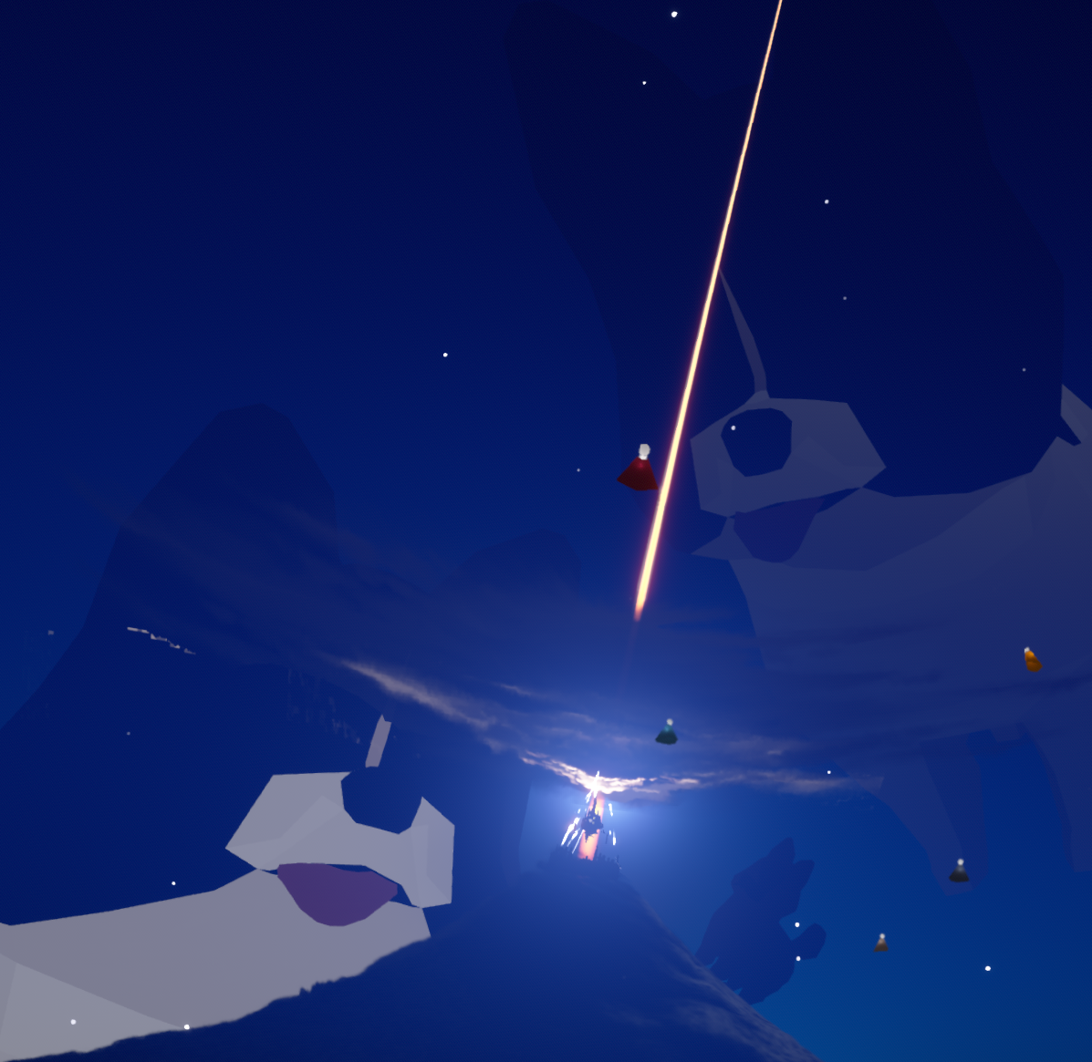

Whatever the hell this event was, no i did not take this pic. Taken by friend Luma

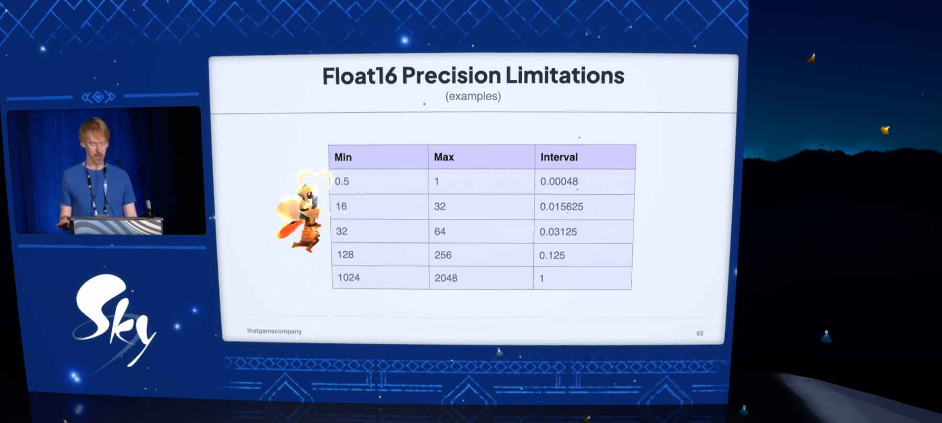

Aurora virtual concert dev talk, he was talking about optimizing data packet encapsulation

Bonus:

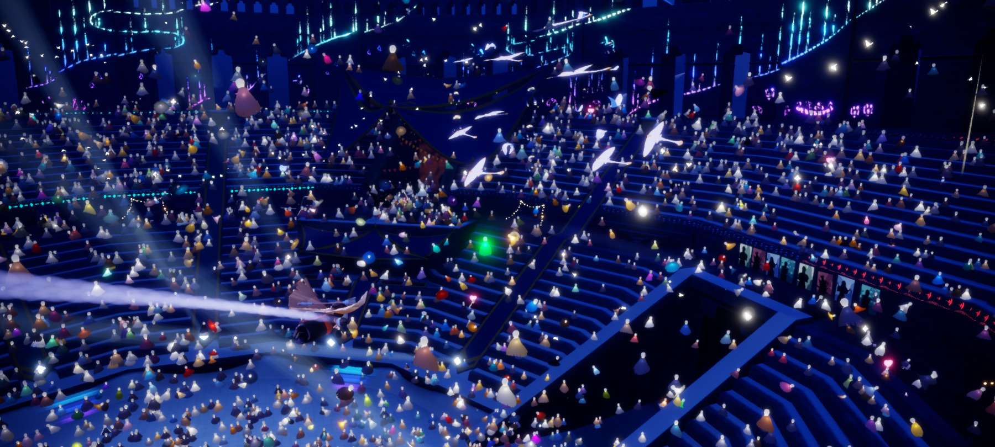

Aurora concert (cant remember if it was actual world record or rehearsal)

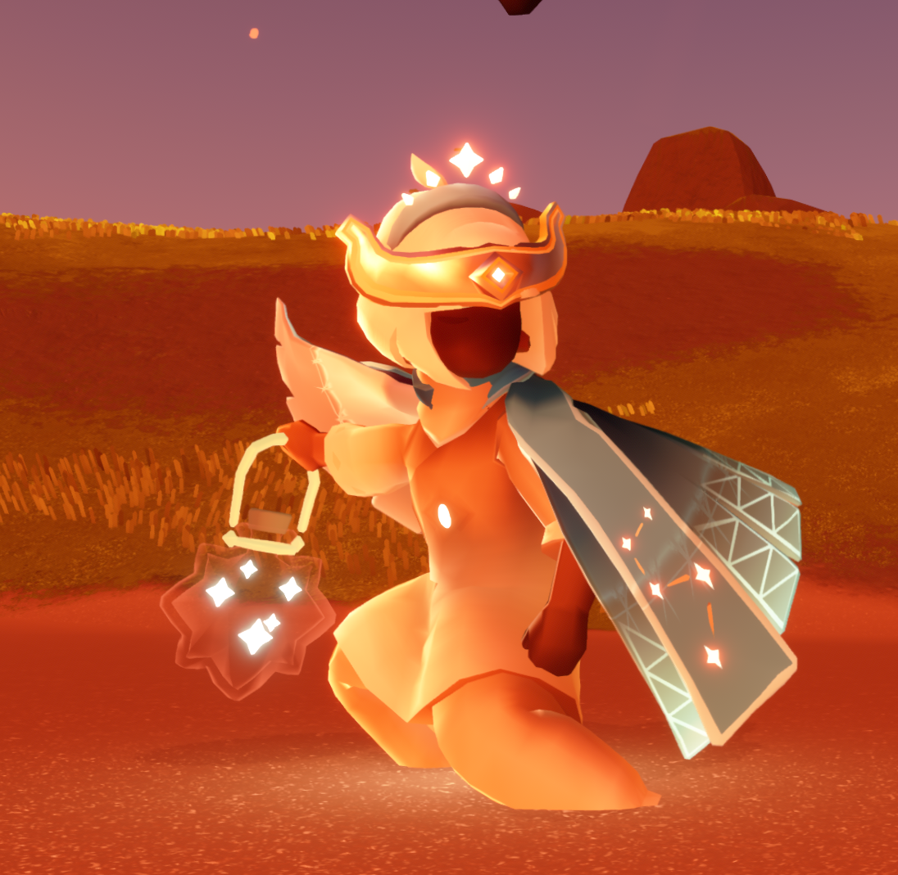

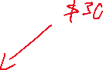

Luma and his dumb pacifier looking anniversary star jar lol

(he exchanged precious game money to get this early. It is one of the most useless props in game by far)

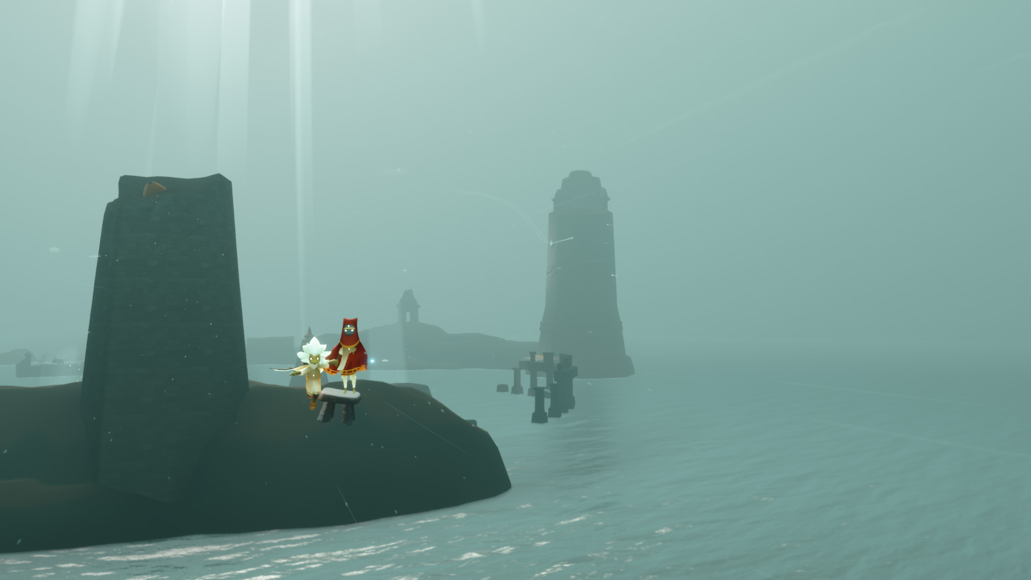



Me and Luma trying to bridge out of bounds (it failed)